Comp 2322 Computer Networking Project:
Multi-thread Web Server

Kwan Tsz Chun Ambrose
24090296D

Introduction
This report outlines the design and implementation of the multi-thread web server, which is a program developed in Python. The programme handles the basic HTTP requests and file handling, which would also output the HTTP response.

Summary of design and implementation of the server program
In the program, each of the files has its own structure and function, which can be combined to establish the system, which will be explained in the following part:
- The server part creates the listening socket and binds it to the host and port from the configuration. After waiting for incoming client connections, it will start a new thread for each connected client.
- The handler part is used to parse the request line and headers. It will check whether the request is in the correct format and determine the connection. After the filter of the handler, it will pass to the response part.

- The response part actually sends back the HTTP response to the client. It will check whether the requested file exists and is readable. It will analyze the file and respond with a different HTTP status. For instance, 200 OK, 304 Not Modified, 403 Forbidden, 404 File Not Found, and 400 Bad Request.
- The longer part will write the request records into the access log, with the modified structure, it will also use a thread lock, which can avoid mixing lines and threads trying to input the logger.
- The config part will store the server settings in one place. It defines the host address, port number, document root folder, log file name, and default page name.
- The client model will connect to the server directly, input the HTTP request for testing the response, and print out the results.
There are three methods to use after starting the server:
- The browser method is the most user-friendly. Open the server address in a browser, and the browser automatically sends the HTTP request and displays the returned page in a visual form. This method is useful for checking whether the website works normally from a user’s point of view, but it gives less control over the exact request details.
- The client.py method is more manual. Type the HTTP request yourself, such as GET /index.html HTTP/1.1, and the client sends exactly what you entered to the server. It then prints the raw response returned by the server. This method is useful for testing specific HTTP requests and understanding how the server handles them, because you can control the request format directly.
- The curl method is a command-line testing approach. Instead of typing the full raw request manually, you use terminal commands such as curl http://127.0.0.1:8000/ or curl -I http://127.0.0.1:8000/index.html. It is faster and more convenient than client.py for common tests, especially when checking headers, status codes, or missing files. However, it is less educational than the custom client for showing the full raw HTTP request structure.

Demonstration of executing the program and screen capturing of the results of all functions

1. GET Command
- Command:
  - http://127.0.0.1:8000/index.html.
- Result: The browser window shows the rendered HTML page, and the socket successfully catches the information and responds with 200 OK.
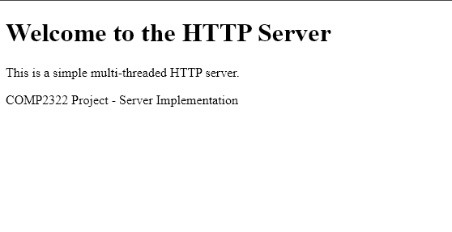
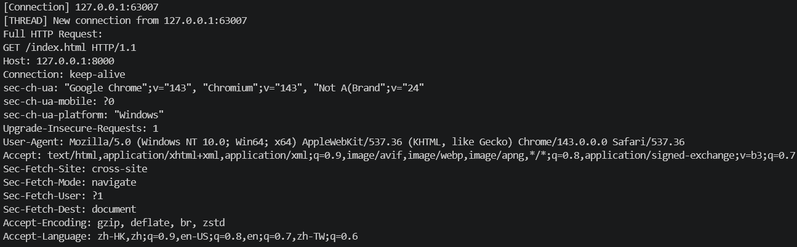
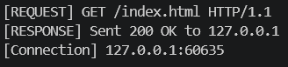
- Command:
  - http://127.0.0.1:8080/test.png
- Result: The browser displays the image directly, and the socket successfully catches the information and responds with 200 OK.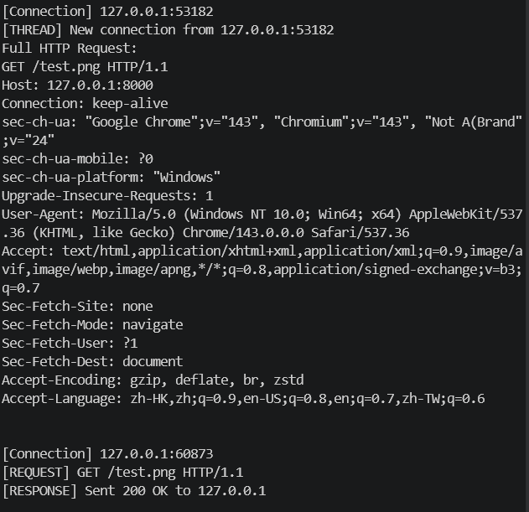

2. HTTP Methods: GET and HEAD
- HEAD Request command:
  - curl -I http://127.0.0.1:8080/index.html
- Result: The terminal shows only the header lines (Status 200 OK, Content-Type, etc.) without the HTML body.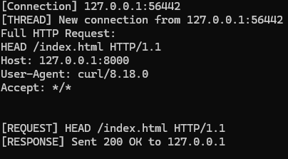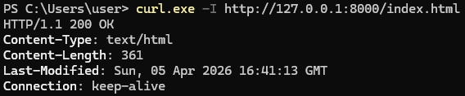
- GET Request:
  - curl -v http://127.0.0.1:8080/index.html
- Result: The terminal shows both the headers and the actual file content.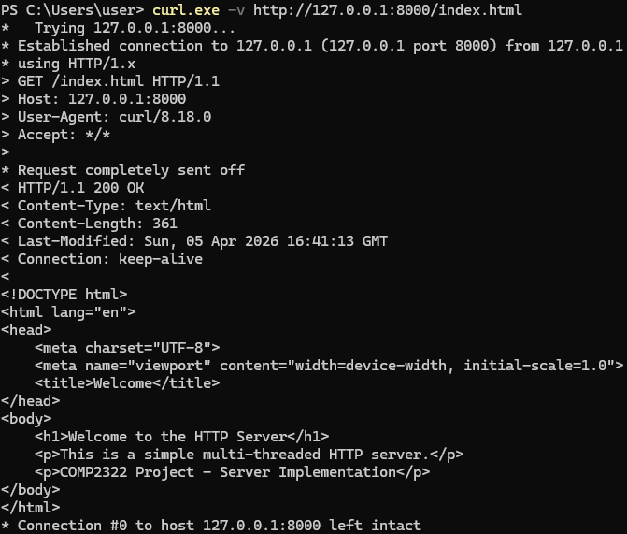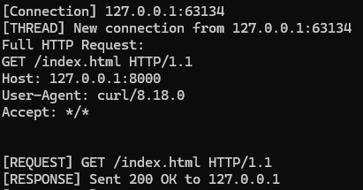

3. All Five Response Statuses
200 OK:
Command:
  - curl.exe -v http:// 127.0.0.1:8000/index.html
Expected result:
  - HTTP/1.1 200 OK
Result:
  - The server successfully catches the messages and responds with the 200 OK
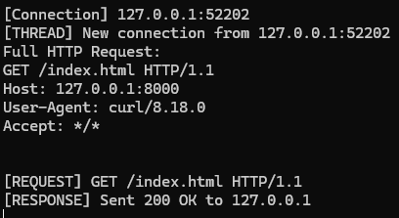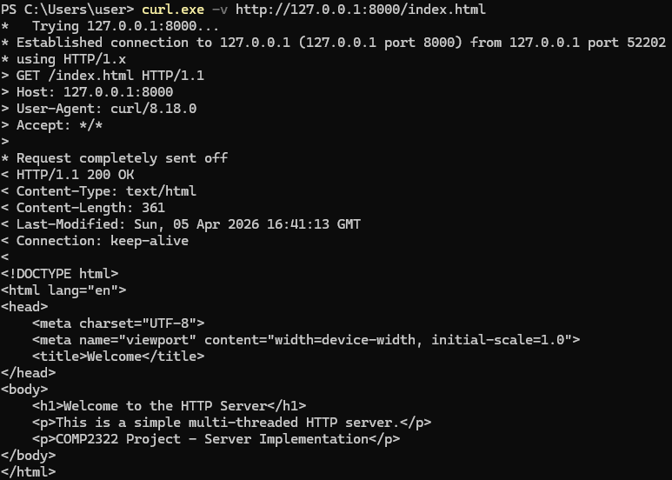
404 Not Found:
- command:
  - curl.exe -v http://127.0.0.1:8000/this_is_not_here.html
- Expected result:
  - HTTP/1.1 404 File Not Found
- Result:
  - Request a file that doesn't exist and responds with the 404 Not Found
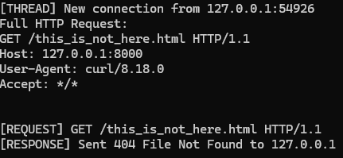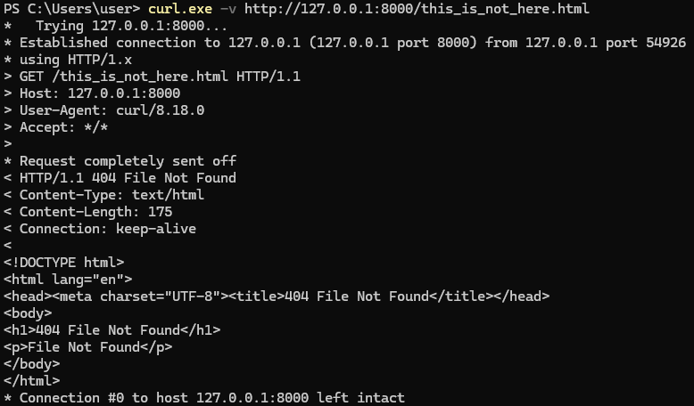
400 Bad Request:
- Command:
  - HELLO-WORLD
- Expected result:
  - HTTP/1.1 400 Bad Request
- Result:
  - Use client.py to send a malformed string that doesn't follow HTTP logic and responds with the 400 Bad Request
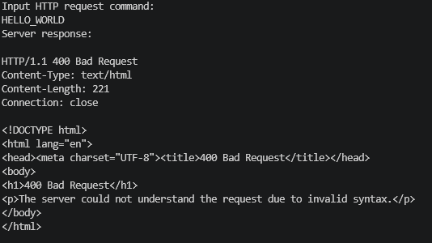
403 Forbidden:
- Command:
  - curl.exe - - path-as-if -v http://127.0.0.1:8000/../server.py
- Expected result:
  - HTTP/1.1 403 Forbidden
- Result:
  - Attempt to access a file where permissions are restricted and responds with the 403 Forbidden
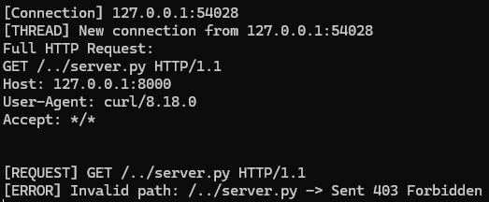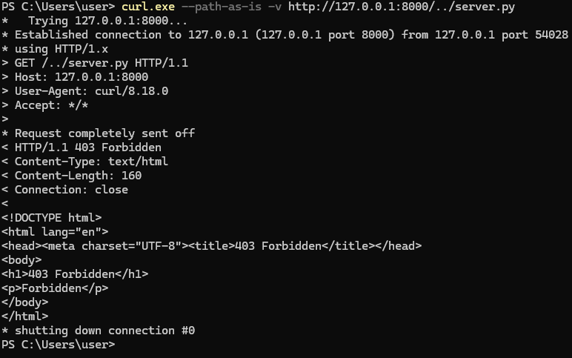
304 Not Modified:
- Command:
  - curl.exe -I http://127.0.0.1:8000/index.html
  - curl.exe -v -H "If-Modified-Since: Fri, 01 Jan 2027 00:00:00 GMT" http://127.0.0.1:8000/index.html
- Expected result:
  - HTTP/1.1 304 Not Modified
- Result:
  - Use curl to send a request with the If-Modified-Since header using a date after the file's last change, and respond with the 304 Not Modified
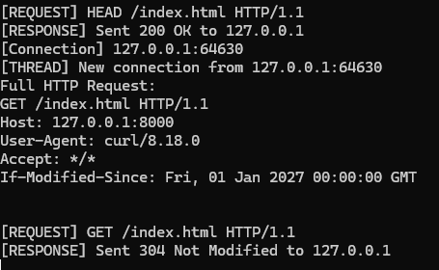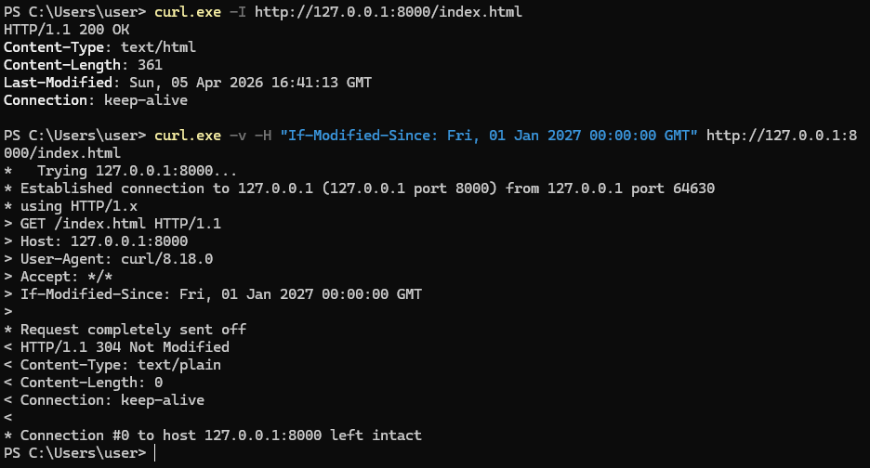

4. Header Handling (Advanced)
- Connection (Keep-Alive):
- Command:
  - curl.exe -v -H "Connection: keep-alive" http://127.0.0.1:8000/index.html
- result:
  - Connection: keep-alive
  - Connection #0 to host 127.0.0.1 left intact
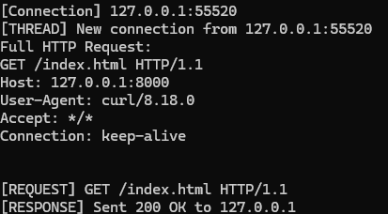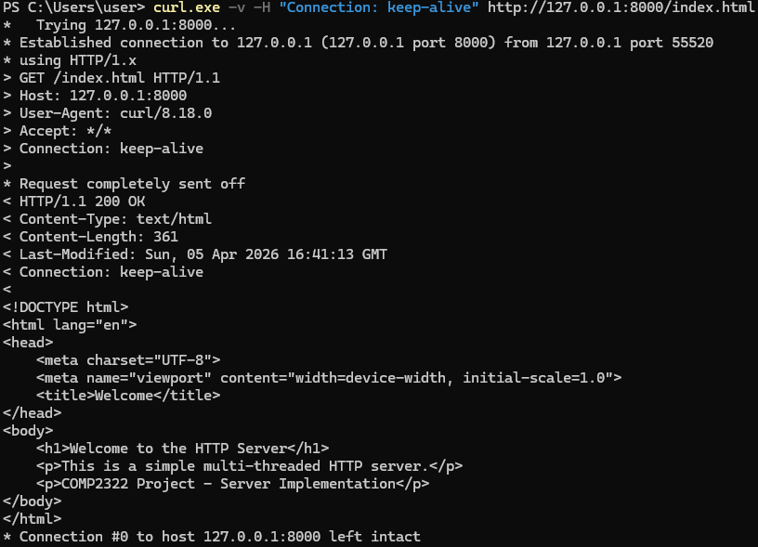
- Connection (Close):
- Command:
  - curl.exe -v -H "Connection: close" http://127.0.0.1:8000/index.html
- result:
  - Connection: close
  - Closing connection 0
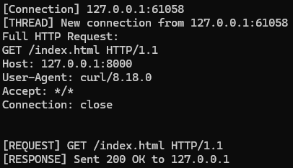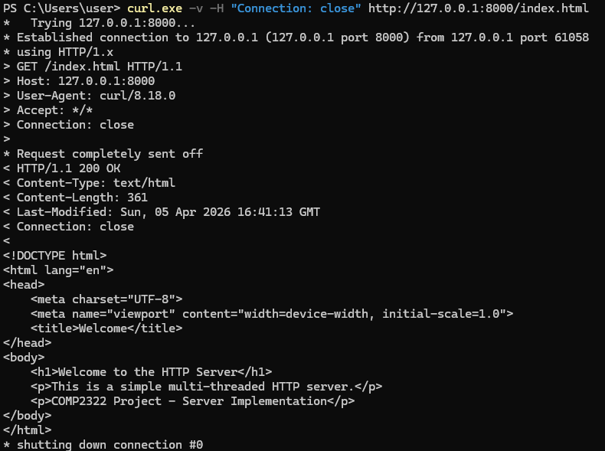
5. Last-Modified:
- Command:
  - curl.exe -I http://127.0.0.1:8000/index.html
- result:
  - Checking the < Last-Modified: Sun, 05 Apr 2026 16:41:13 GMT
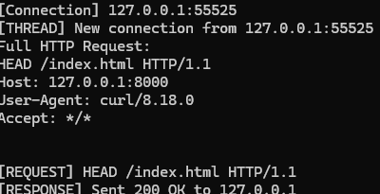
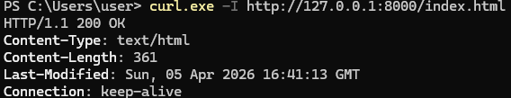

5. Multi-threading & Logging
Prove the server can handle "multiple requests at the same time".
- Multi-threading:
  - Use client.py to send multiple requests rapidly.
Result: server console shows multiple "Thread started" and "Connection accepted" messages appearing simultaneously.